
Project Documentation
ETL Process for Medicare Inpatient Data 2017

October 23, 2026
BY: Ritesh Chaudhary

Table of Contents
1. Abstract 3
2. Introduction 3
3. Project Scope 3
4. About Source System & Data Description 3
5. ER Diagram 4
6. ETL Architecture Overview 4
7. Data Flow Diagram 5
8. Schema Structure & Rationale 5
9. Bulk Insert Strategy 6
10. Raw Layer (Staging) Processing 6
11. Clean/Transformed Layer Processing 7
12. Fact & Dimension Table Design (Star Schema) 8
Dimension Tables 8
District 8
Doctor 8
DRG (Diagnosis Related Group) 9
Patient 9
Fact Table 10
Hospitalization 10
13. Business Analytical Queries and PowerBI Visual with Explanation 10
Query 1: Which DRG treatments generate the highest revenue? 11
Query 2: Which districts are the strongest markets for the hospital? 12
Query 3: Which doctors contribute the most revenue while handling significant case volumes? 13
Query 4: Which DRGs have high patient volume but relatively low revenue per case? 14
Query 5: What is the month-over-month revenue growth trend? 15
Query 6: Which doctors have unusually high or low cure rates? 16
Query 7: How does length of stay affect revenue and operational demand? 17
Query 8: Which DRGs have both high revenue and high mortality? 18
Query 9: What percentage of gross amount is represented by discounts? 19
Query 10: Which district–DRG combinations have the highest hospitalization demand? 20
14. Data Quality & Validation Rules 21
15. Advantages of ETL Process 21
16. Disadvantages / Challenges 21
17. Acknowledgment 21
18. Conclusion 21
19. Glossary 22

1. Abstract
This ETL documentation report presents a comprehensive, end-to-end data engineering workflow designed to extract, transform, and load healthcare-related inpatient records into a structured analytical data warehouse. The system follows a multi-layer architecture utilizing raw staging, cleaned transformation tables, star-schema modeling, and optimized SQL-based workflows.
Visual ER diagrams, data flow models, and SQL scripts are included to illustrate the technical foundation. The project incorporates business analytical queries that support decision-making.

2. Introduction
Modern healthcare institutions generate large volumes of clinical and administrative data. This project focuses on developing an ETL pipeline that processes patient hospitalization data into meaningful analytical insights. SQL Server is used as the main RDBMS, with structured ingestion from CSV files into a multi-layer ETL environment.
The system analyzes DRG categories, financial metrics, doctor performance, mortality, demographic trends, and collection reports.

3. Project Scope
The ETL project includes the following:
- Extracting structured CSV files containing inpatient records.
- Designing logical and physical schemas.
- Bulk loading data from external sources.
- Cleansing and transforming data.
- Building a star schema for analytical processing.
- Developing 10 analytical queries.
- Implementing data quality checks.
- Documenting all technical steps.

4. About Source System & Data Description
The source dataset originates from hospital inpatient records containing fields such as DRG code, patient name, district, doctor, admission/discharge dates, gender, age, financials, and treatment outcomes. The source format is a delimited CSV file, uploaded as part of the ETL ingestion pipeline.

5. ER Diagram
The following ER model represents the logical relationship between dimension tables like patients, doctors, districts, DRG details, and hospitalization facts.
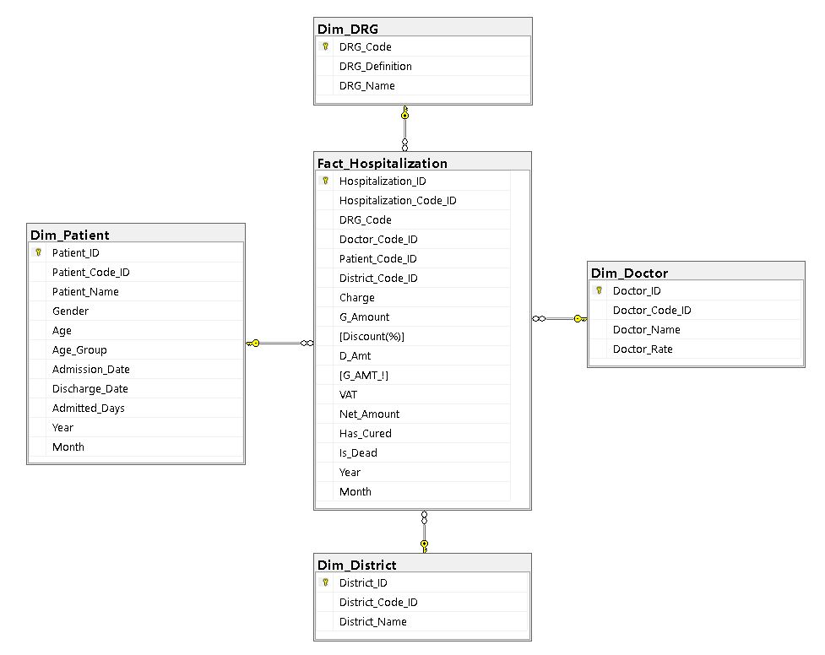
Fig 1: ER Diagram (Star Schema)

6. ETL Architecture Overview
A multi-layer ETL structure is used, including:
- Source Layer – Raw CSV files.
- Staging Layer (Raw Schema) – Temporary tables for storing unprocessed data.
- Transform Layer (Clean Schema) – Standardized and validated tables.
- Data Warehouse Layer (DWH Schema) – Star Schema (Fact + Dimensions)
- Consume Layer – For Business Insights (Reporting)

7. Data Flow Diagram
The data flow diagram (DFD) outlines how the data moves through extraction, transformation, and loading until delivered to analytics.
The DFD outlines these steps:
- CSV File Extraction
- Bulk Load into Raw Schema
- Cleansing & Transformations & Load into Clean Schema
- Loading into Fact and Dimension tables with keys mapping
- 10 Business Queries for Reporting
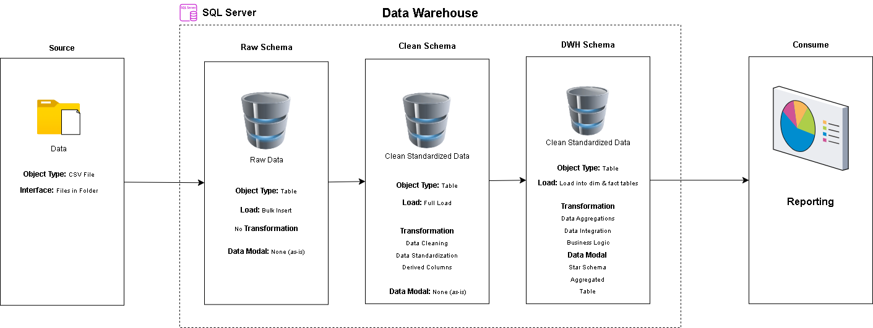
Fig 2: DFD (Data Flow Diagram)

8. Schema Structure & Rationale
Three schemas were used purposely:
Schema | Purpose
Raw Schema | Holds unmodified bulk-loaded data
Clean Schema | Stores cleaned, validated, and standardized data
DWH Schema | Contains star schema tables for analytics

Advantages of Schema Separation
- Layer-wise separation improves maintainability
- Ensure traceability from source, staging and final tables.
- Prevents contamination of analytical data.
- Allows independent auditing, rollback, and quality checks.

9. Bulk Insert Strategy
High-volume ingestion uses SQL Server’s BULK INSERT mechanism.
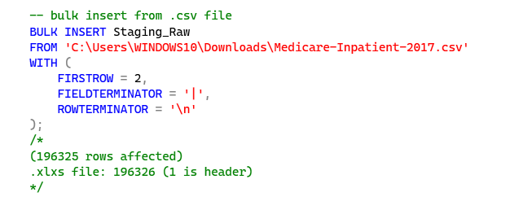
Fig 3: Bulk insert
The objective is high-speed ingestion with minimal overhead.

10. Raw Layer (Staging) Processing
Raw data is inserted without modification. This stage helps:
- Capture original data for audit
- Detect Anomalies
- Prevent mixing raw and processed data
- Enable repeatability during pipeline reruns
Raw Staging Table Structure:
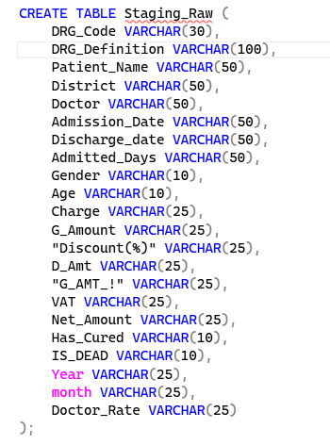
Fig 4: Raw Staging Table Structure
At this stage every data is stored from ‘Bulk Insert” in text format. Later data are transformed into different data types.

11. Clean/Transformed Layer Processing
The clean layer corrects formatting issues and ensures data consistency.
Clean Staging Table Structure:
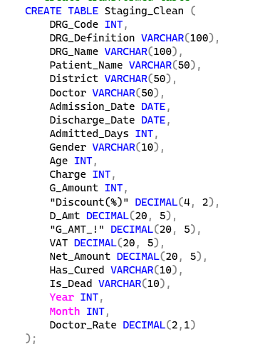
Fig 5: Clean Staging Table Structure
Clean Data Insert:
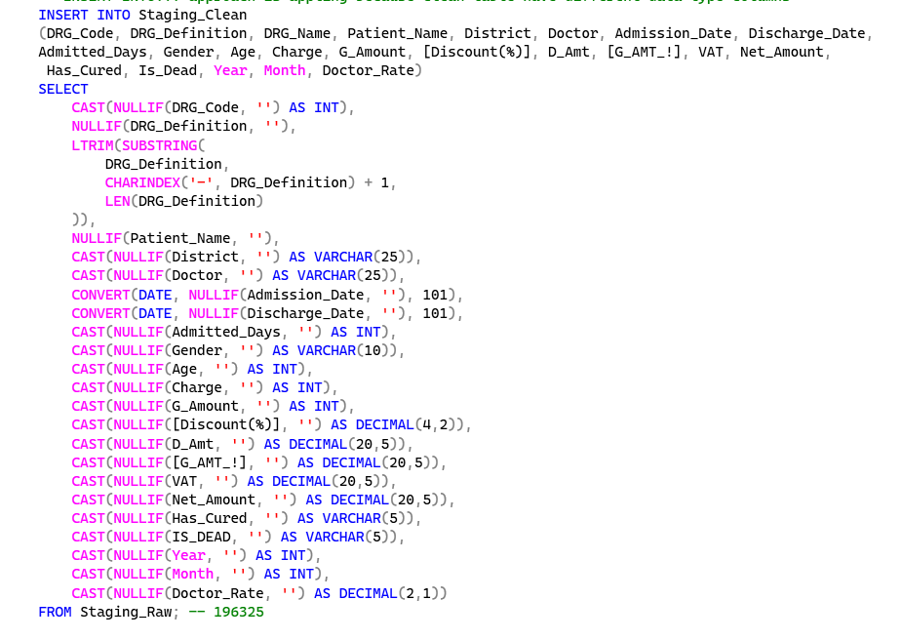
Fig 6: Clean Data Insert
Transformations performed:
- Trimming text
- Converting data types
- Handling nulls
- Ensuring valid dates

12. Fact & Dimension Table Design (Star Schema)
The Star schema enhances analytical performance.

Dimension Tables

District
Table structure and insert data
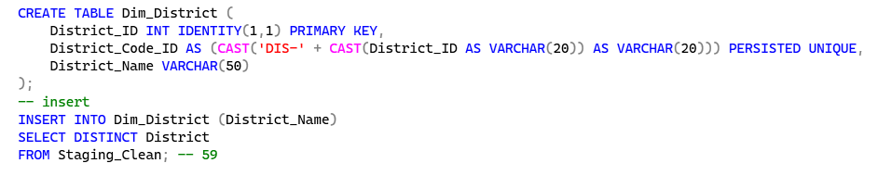
Fig 7: Dimension District Table Structure & Insert Distinct Data

Doctor
Table structure and insert data
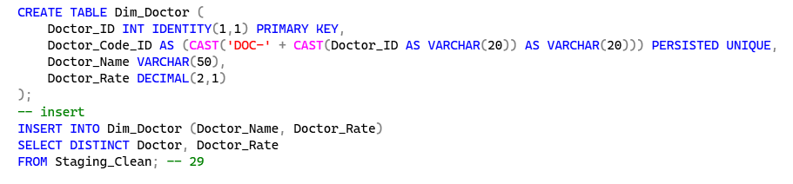
Fig 8: Dimension Doctor Table Structure & Insert Distinct Data

DRG (Diagnosis Related Group)
Table structure and insert data
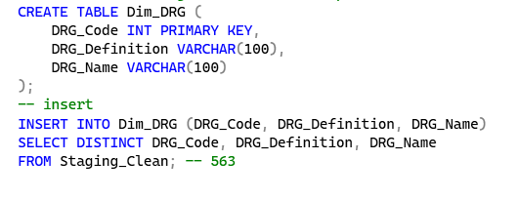
Fig 9: Dimension DRG Table Structure & Insert Distinct Data

Patient
Table structure and insert data
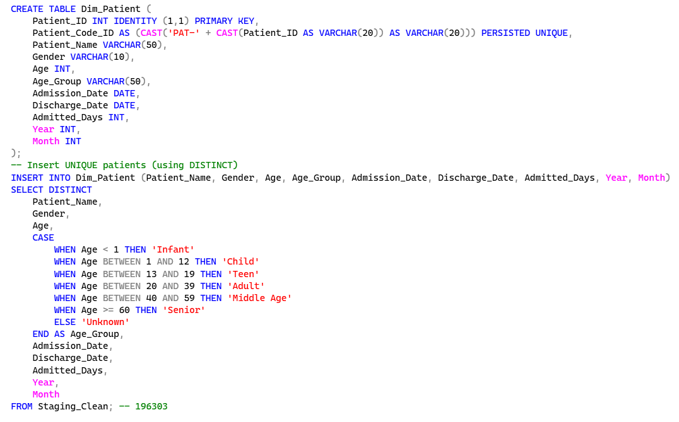
Fig 10: Dimension Patient Table Structure & Insert Distinct Data

Fact Table
Stores measures such as charges, VAT, Net amount, etc.

Hospitalization
Table structure and insert data
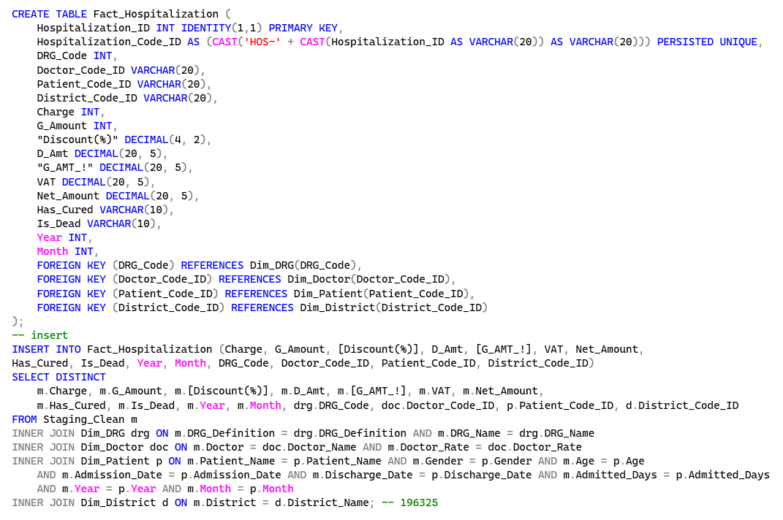
Fig 11: Fact Hospitalization Table Structure & Insert Distinct Data

13. Business Analytical Queries and PowerBI Visual with Explanation
Below are the 10 business analytical SQL queries used in this ETL project. Each query is included exactly as provided in the project and described in paragraph form.

Query 1: Which DRG treatments generate the highest revenue?
Question: Which top 20 DRG treatment categories generate the highest total revenue, and how do they rank against other treatments?
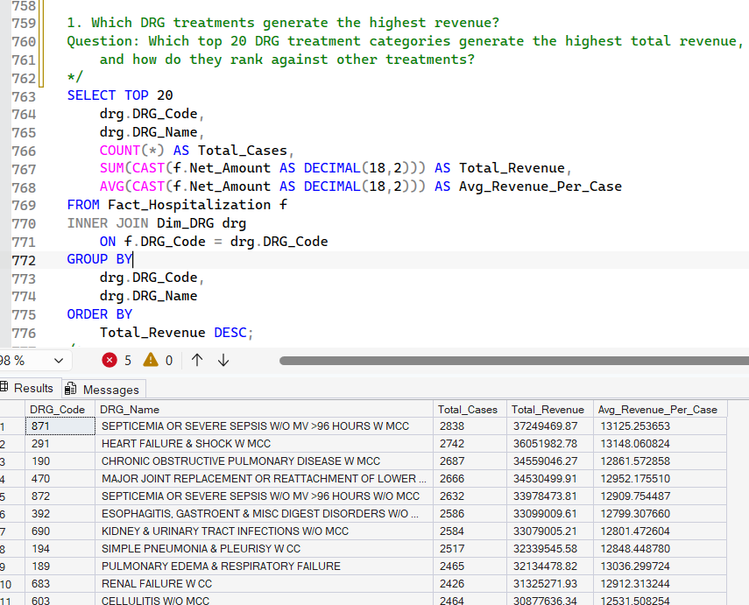
Fig 11: Top 20 DRG Treatments by Revenue Query
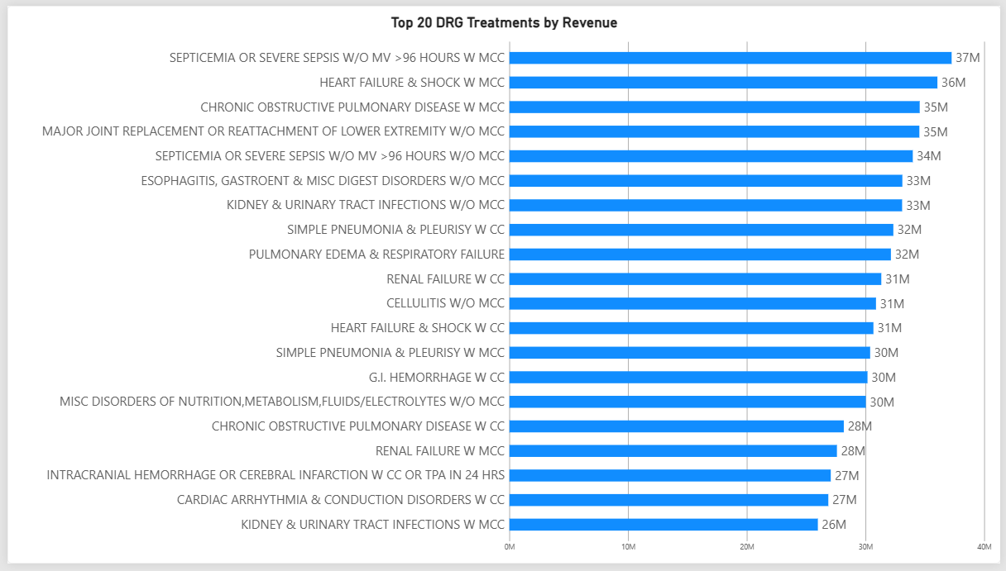
Fig 12: Top 20 DRG Treatments by Revenue Visual
Business Value:
Management can identify the highest-revenue treatment categories and use the result for resource allocation, capacity planning and service strategy.

Query 2: Which districts are the strongest markets for the hospital?
Question: Which geographic districts contribute the most patients and revenue, and which districts may represent growth opportunities?
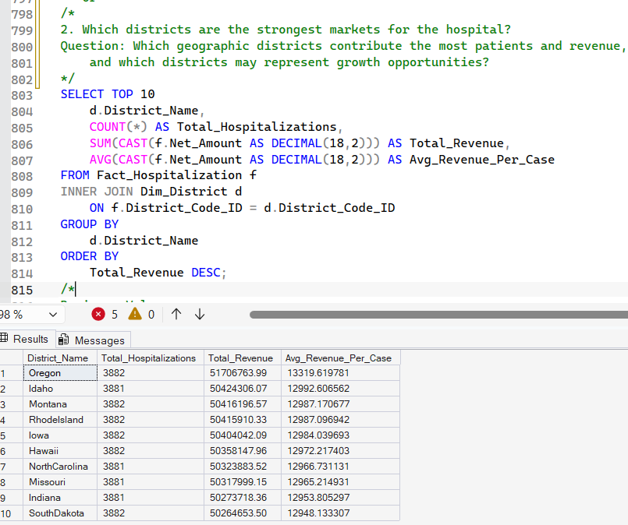
Fig 14: Top 10 District by Hospital Revenue Query
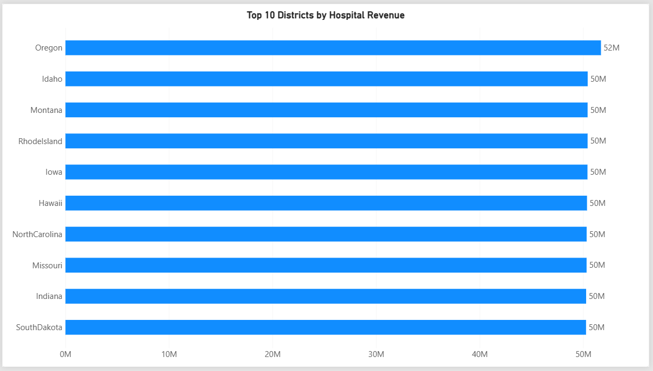
Fig 15: Top 10 District by Hospital Visual
Business Value: This can support regional marketing, referral partnerships and service expansion decisions.

Query 3: Which doctors contribute the most revenue while handling significant case volumes?
Question: Which doctors generate the highest revenue while managing a significant number of hospitalizations?
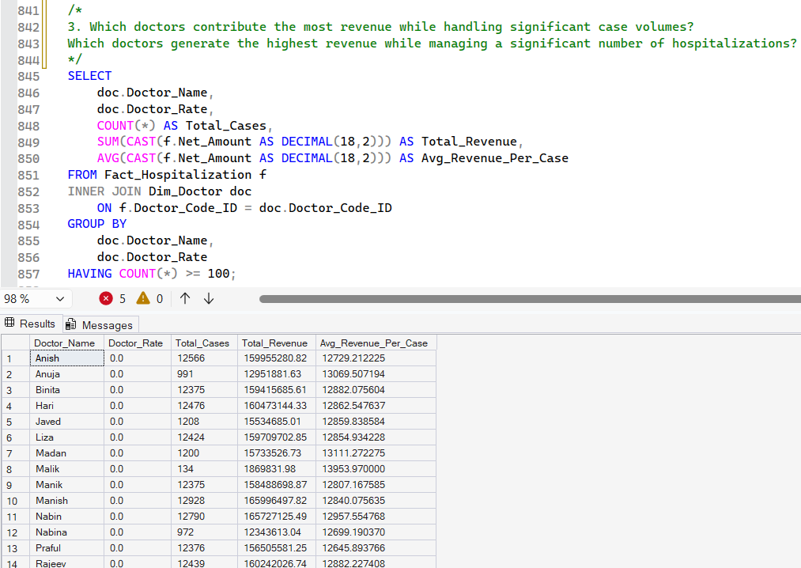
Fig 16: Doctor Revenue vs Hospitalization Volume Query
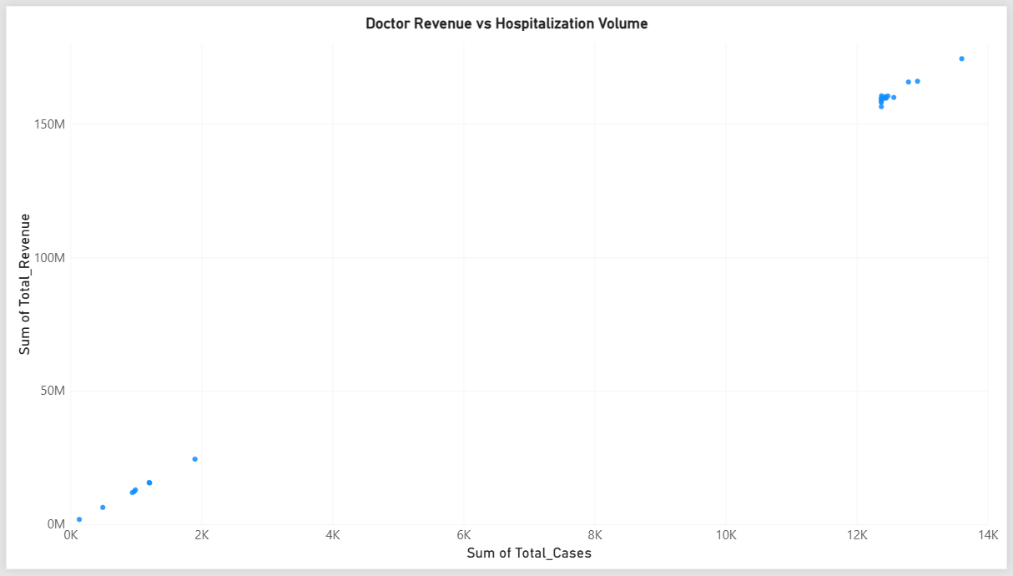
Fig 17: Doctor Revenue vs Hospitalization Volume Visual
Business Value: Useful for workforce planning, workload analysis, capacity management and incentive analysis.

Query 4: Which DRGs have high patient volume but relatively low revenue per case?
Question: Which treatments have high demand but comparatively low revenue per hospitalization?
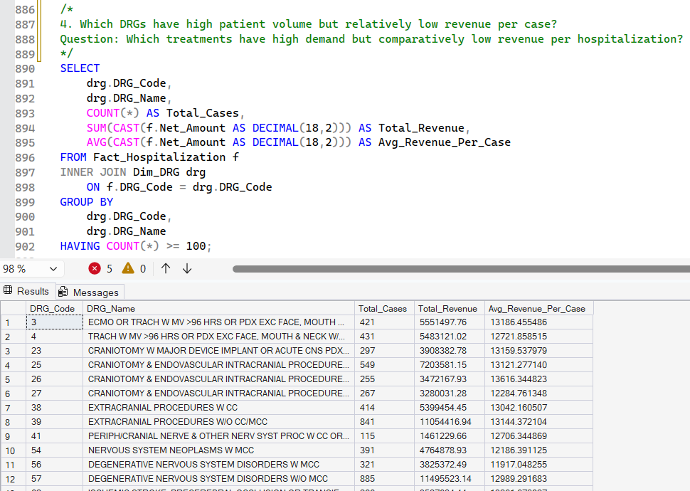
Fig 18: DRG Volume vs Revenue per Case Query
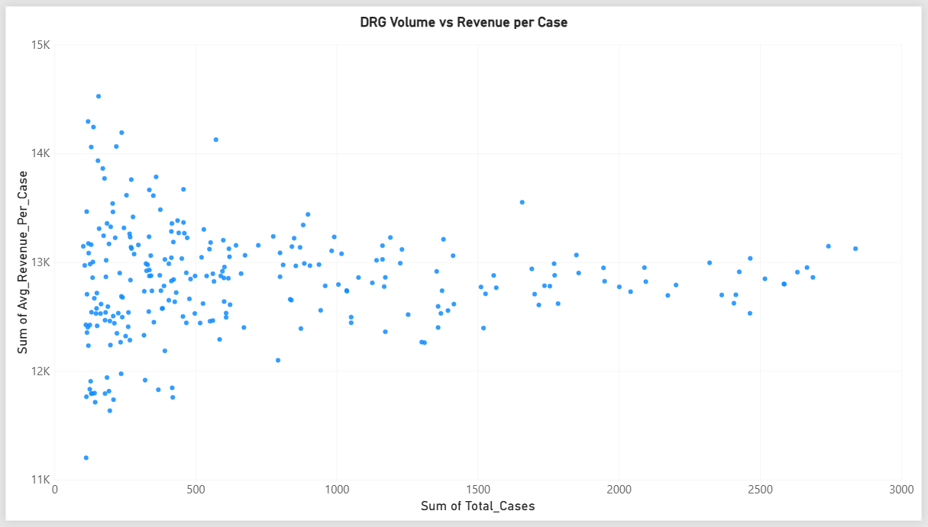
Fig 19: DRG Volume vs Revenue per Case Visual
Business Value: A high-volume/low-revenue service may require management to investigate pricing, reimbursement, operational cost or resource utilization.

Query 5: What is the month-over-month revenue growth trend?
Question: How is hospital revenue changing month-over-month, and which months experienced the strongest growth or decline?
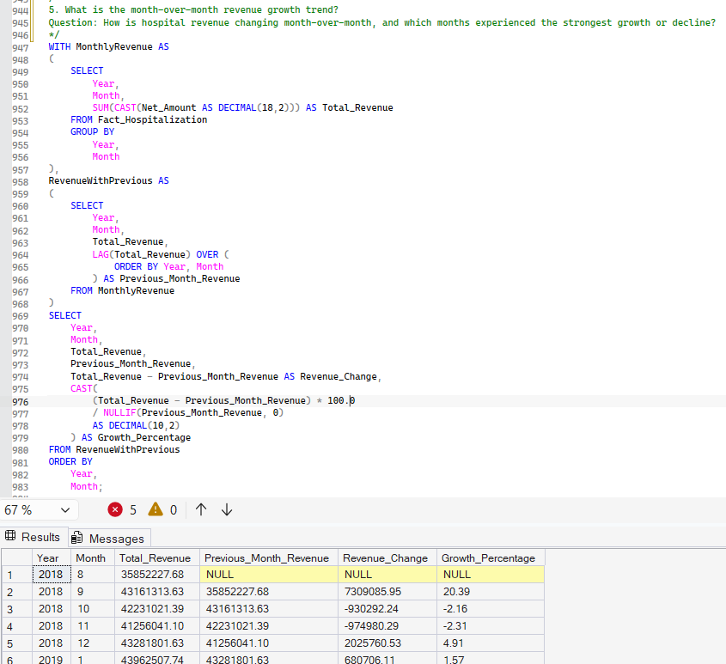
Fig 20: Monthly Hospital Revenue Trend Query
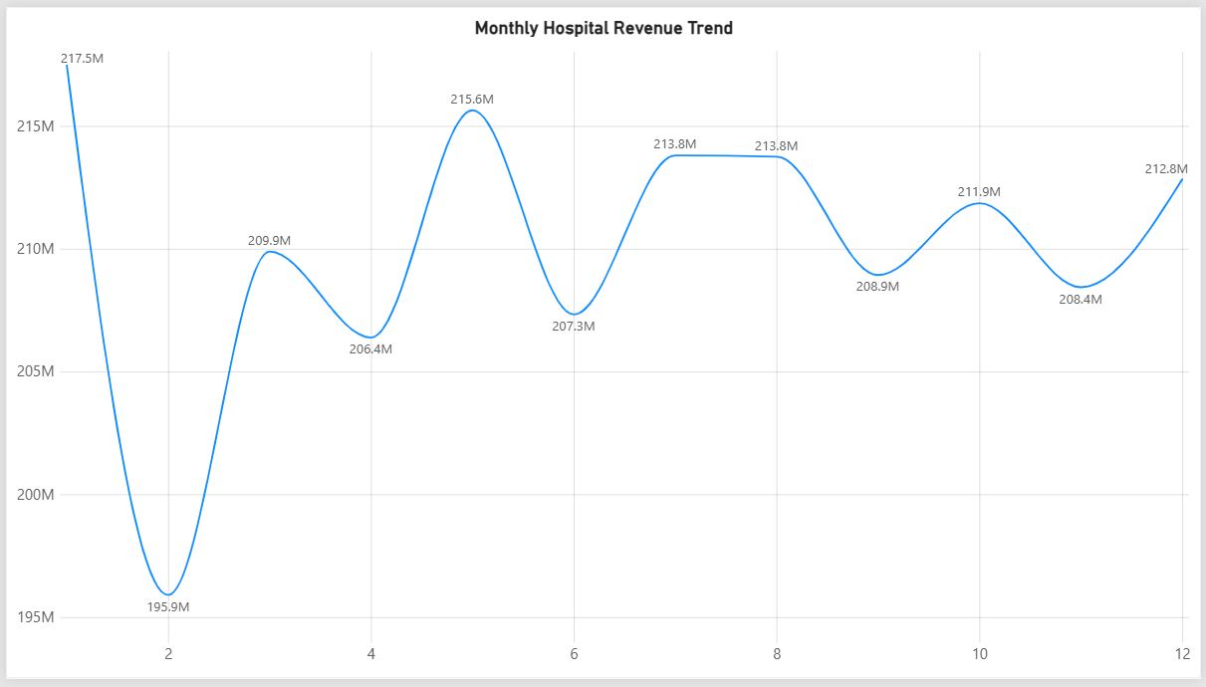
Fig 21: Monthly Hospital Revenue Trend Visual
Business Value: Helps Management can identify growth periods, declining periods and seasonal demand patterns for staffing and resource planning.

Query 6: Which doctors have unusually high or low cure rates?
Question: Which doctors have the highest and lowest observed cure rates?
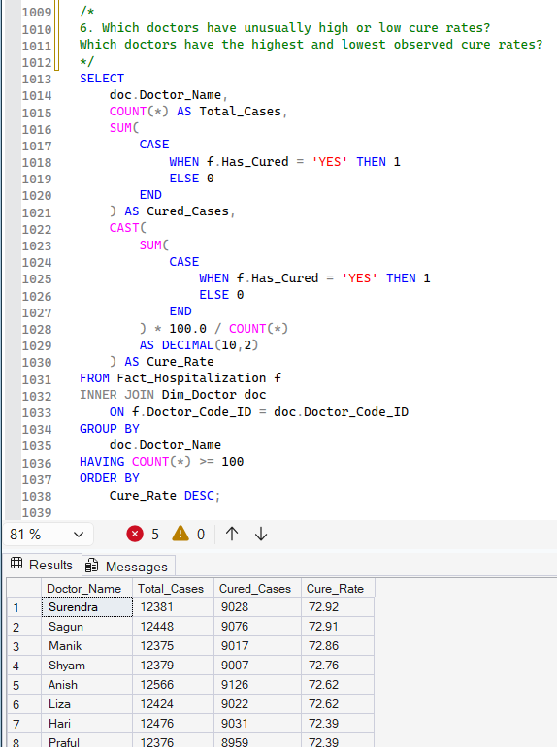
Fig 22: Revenue by Doctor and Month Query
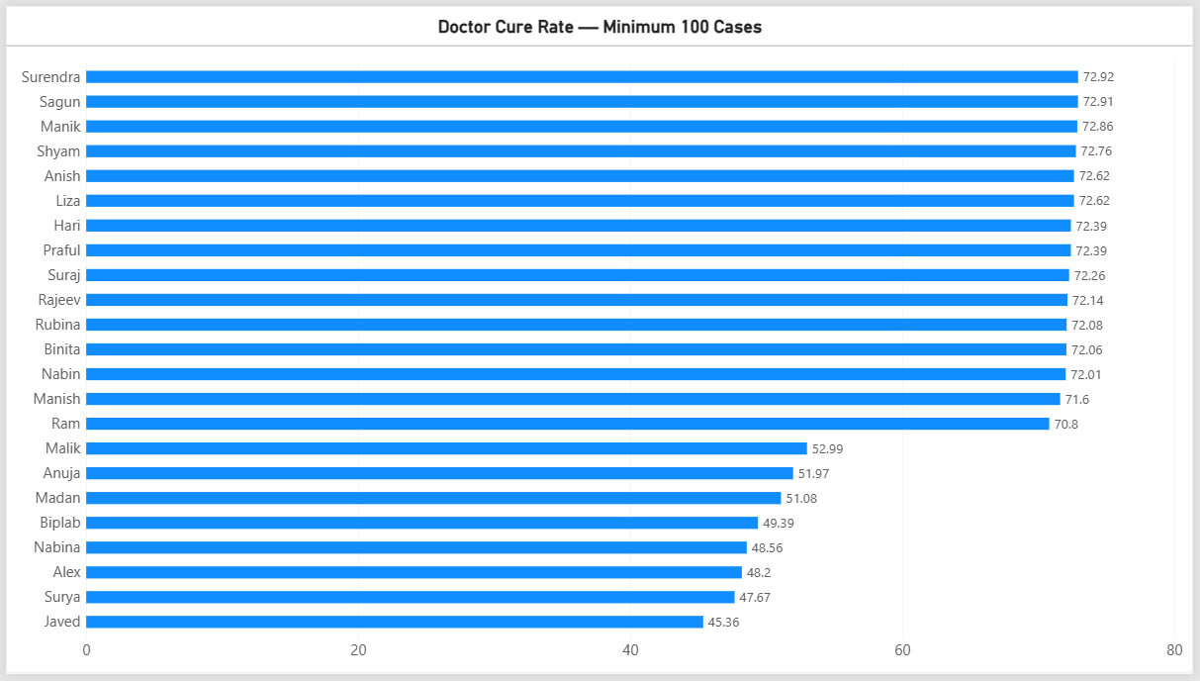
Fig 23: Revenue by Doctor and Month PowerBI Visual
Business Value: Useful as a quality-monitoring indicator, but it should not be interpreted as proof that one doctor provides better care because diagnosis severity and patient mix can differ.

Query 7: How does length of stay affect revenue and operational demand?
Question: How do short-, medium- and long-stay hospitalizations differ in volume and revenue?
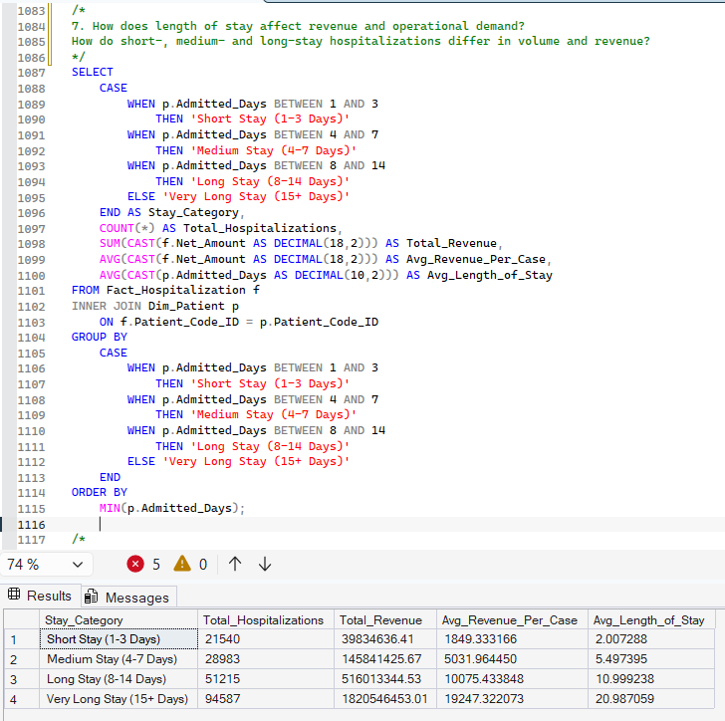
Fig 24: Hospitalization Volume and Revenue by Length of Stay Query
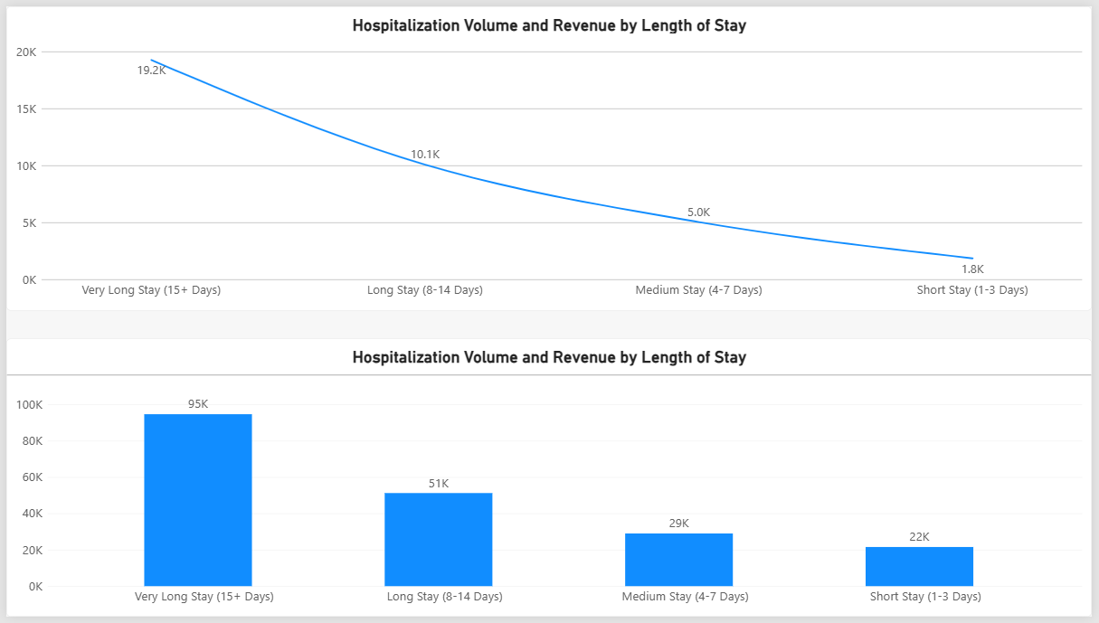
Fig 25: Hospitalization Volume and Revenue by Length of Stay Visual
Business Value: Helps with bed capacity, staffing, operational planning and long-stay management.

Query 8: Which DRGs have both high revenue and high mortality?
Question: Which major treatment categories require management attention because they combine substantial financial activity with elevated mortality?
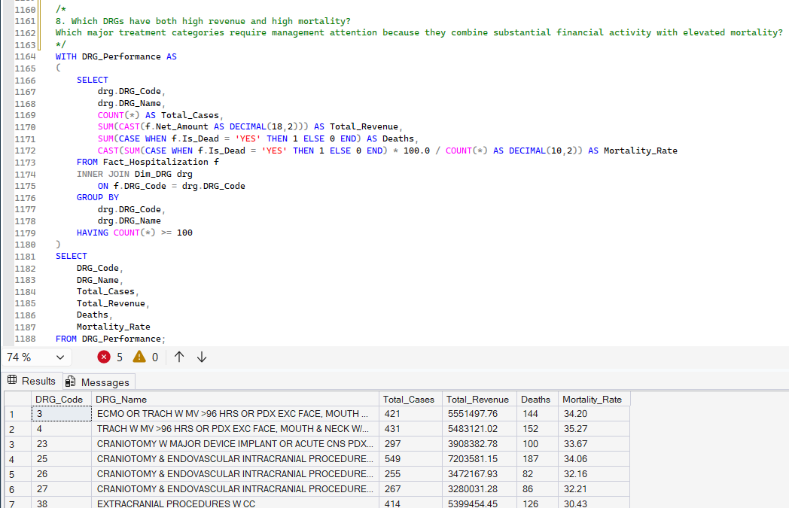
Fig 26: DRG Revenue vs Mortality Query
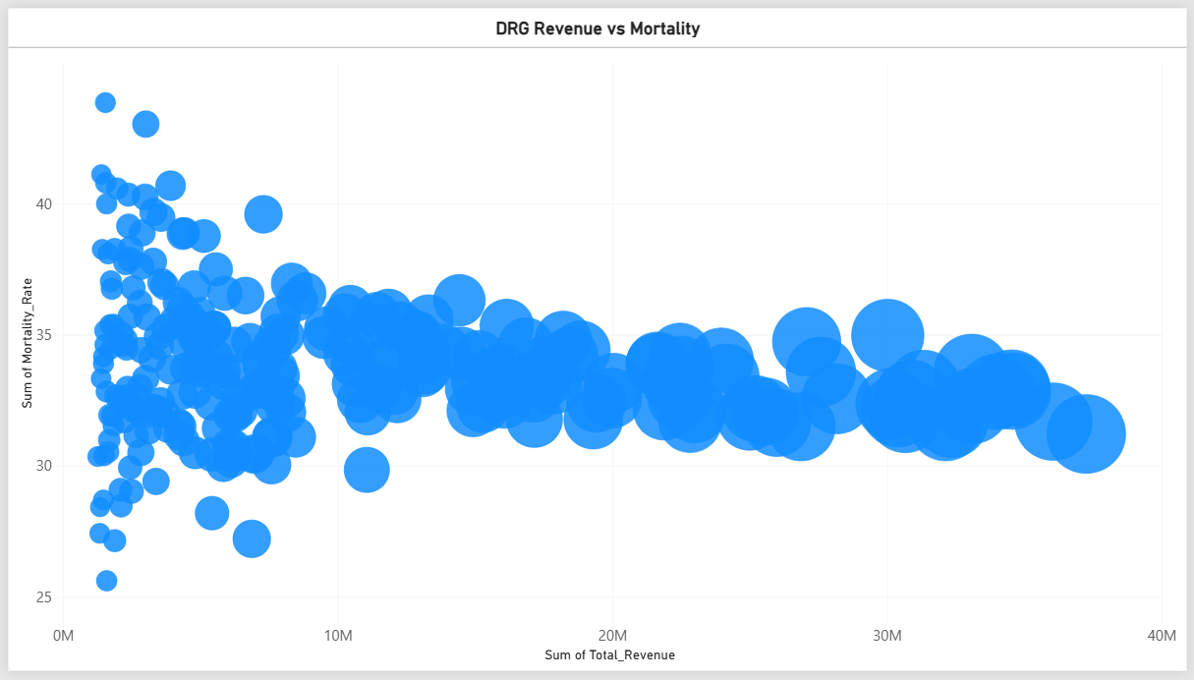
Fig 27: DRG Revenue vs Mortality Visual
Business Value: This identifies areas where financial importance and clinical risk intersect.

Query 9: What percentage of gross amount is represented by discounts?
Question: How much revenue is being reduced through patient discounts, and what is the effective discount rate?
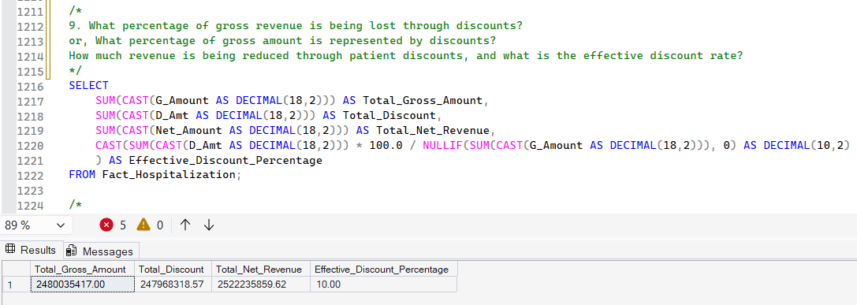
Fig 28: Gross amount, discounts and net revenue Query
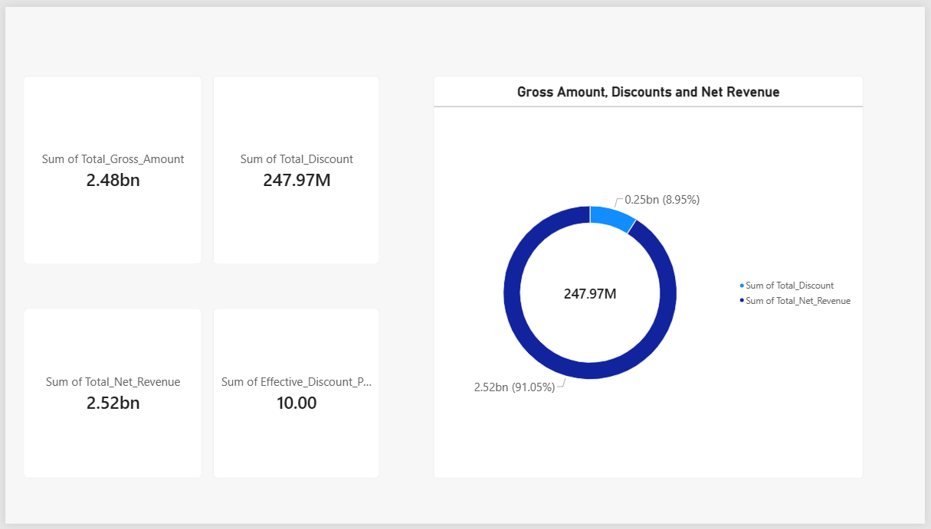
Fig 29: Gross amount, discounts and net revenue Visual
Business Value: Supports discount-policy evaluation, revenue optimization and financial reporting.

Query 10: Which district–DRG combinations have the highest hospitalization demand?
Question: Which combinations of geographic district and treatment category generate the highest hospitalization volume?
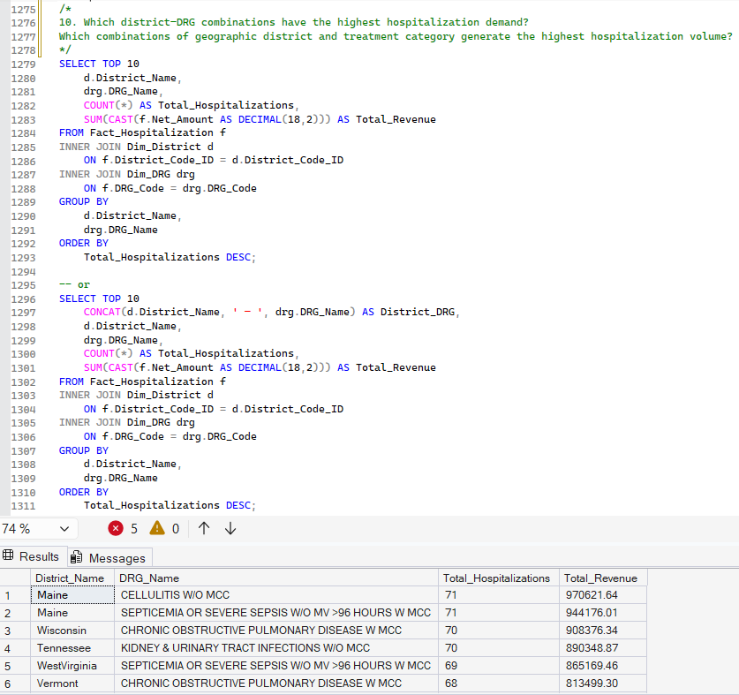
Fig 30: Top 10 District-DRG combinations by Hospitalization Demand Query
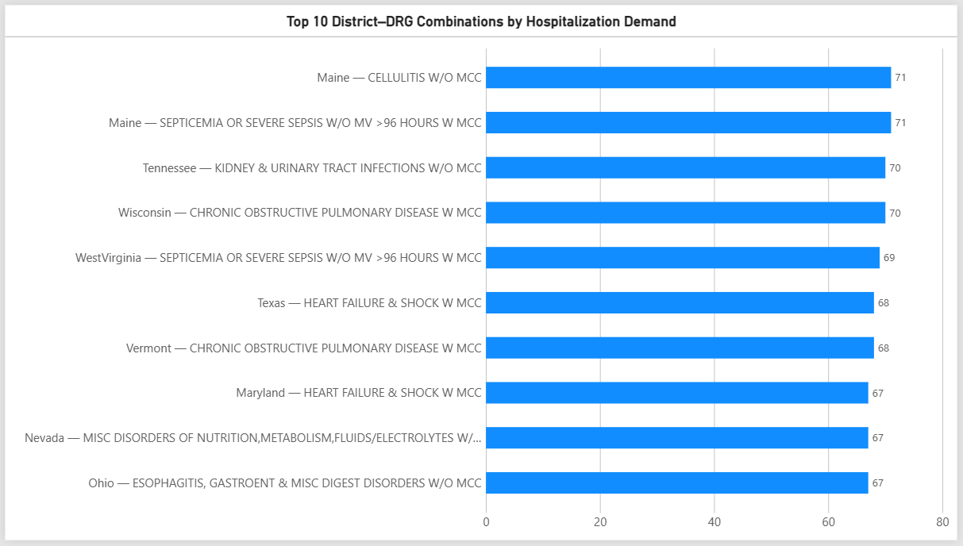
Fig 31: Top 10 District-DRG combinations by Hospitalization Demand Visual
Business Value: Management can identify where specific treatments have the highest demand, which can support specialist allocation and regional service planning.

14. Data Quality & Validation Rules
The project includes multi-level checks:
- Null validation / Missing value checks
- Date validation
- Numeric field verification
- Standardization (whitespace trim)

15. Advantages of ETL Process
- Provides a single source of truth by integrating raw data into a clean fact table.
- Ensures data quality via transformation and validation.
- Improves query performance by standardizing data types and indexing.
- Enables business insights through advanced analytics queries.

16. Disadvantages / Challenges
- High development time for writing and maintaining SQL scripts.
- Scalability issues if dataset grows beyond millions of records.
- Bulk insert requires strict file format consistency (delimiters, headers).
- Potential data loss if invalid rows are not handled properly during transformation.

17. Acknowledgment
This project is based on the Medicare Inpatient 2017 dataset. The ETL process was implemented using Microsoft SQL Server and SQL Server Management Studio (SSMS).

18. Conclusion
This ETL project demonstrates a robust data engineering strategy for transforming raw patient data into a well-structured analytical warehouse. The layered architecture ensures traceability, accuracy, and high performance. The analytical queries provide actionable insights into hospital operations and patient care.

19. Glossary
The glossary defines key technical terms used throughout the ETL documentation. It includes definitions for ETL concepts such as “staging layer,” “data warehouse,” and “fact table,” along with industry-specific terms such as DRG, mortality indicator, VAT, and net amount. Providing these definitions ensures clarity for readers from both technical and non-technical backgrounds.
Such as:
- ETL: Extract, Transform, Load
- DRG: Diagnosis Related Group
- DWH: Data Warehouse
- OLAP: Online Analytical Processing
- Raw Layer: Ingestion layer holding unprocessed data
- Staging: Temporary processing layer
- Fact Table: Table containing measurable business data
- Dimension Table: Table describing attributes/context of facts
- VAT: Value Added Tax

